**“GRUBHUB”**

### A PROJECT REPORT

### *Submitted by*

**SWATI MANOJ THAKUR**

**180640116032**

#### *In partial fulfillment for the award of the degree of*

## BACHELOR OF ENGINEERING

***in***

**INFORMATION TECHNOLOGY**

**K J INSTITUTE OF ENGINEERING AND TECHNOLOGY**

 

## Gujarat Technological University, Ahmedabad

**May, 2022**



**K J Institute Of Engineering & Technology**  
**Opp. ITI, Javla-Savli, PO. Savli – 391770**

# CERTIFICATE

This is to certify that the project report submitted along with the project entitled **GrubHub** has been carried out by **SWATI MANOJ THAKUR** under my guidance in partial fulfillment for the degree of Bachelor of Engineering in Information Technology, 8th Semester of Gujarat Technological University, Ahmadabad during the academic year 2021-22.

Mr. Jitendrasinh Gunvantsinh Raulji Mr Vikas Singh

Internal Guide Head of the Department

**COMPANY CERTIFICATE**

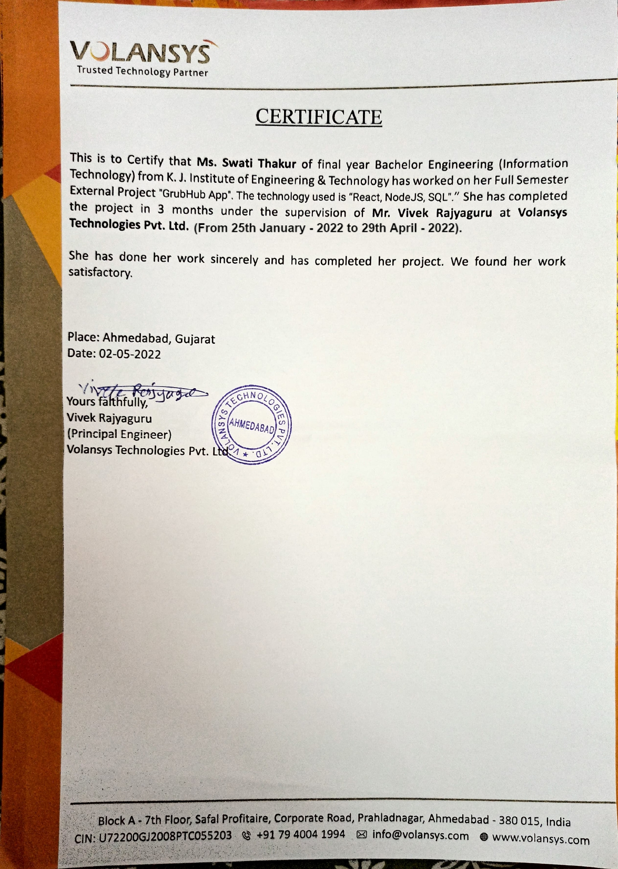



**K J Institute Of Engineering & Technology**  
**Opp. ITI, Javla-Savli, PO. Savli – 391770**

DECLARATION

GTU  Logo  
We hereby declare that the Internship report submitted along with the Internship entitled “**GRUBHUB**” submitted in partial fulfillment for the degree of Bachelor of Engineering in to Gujarat Technological University, Ahmedabad, is a bonafide record of original project work carried out by me at **VOLANSYS TECHNOLOGIES Pvt. Ltd** under the supervision of **Mr. Vivek Rajyaguru and Mr. Jitendrasinh Raulji** and that no part of this report has been directly copied from any students’ reports or taken from any other source, without providing due reference.

**SWATI MANOJ THAKUR**

Name of the Student Sign of Student

**ACKNOWLEDGMENT**

The satisfaction that accompanies the successful completion of this project would be incomplete without mentioning the people who made it possible, without whose constant guidance and encouragement would have made eforts go in vain. I consider myself privileged to express gratitude and respect towards all those who has guided through the completion of projects.

I convey thanks to my project guide **Mr. Jitendrasinh Gunvantsinh Raulji**, Information Technology Engineering department, KJIT for providing encouragement, constant support and guidance which was of a great help to complete this project work successfully.

I am grateful to my external guide **Mr.Vivek Rajyaguru, Principal Engineer** in **Volansys Technologies Pvt. Ltd.** for giving me the support and encouragement that was necessary for the completion of this project.

I am grateful to **Mr. Vikas Singh**, Head of the Department, Information Technology Engineering, KJIT for giving us the support and encouragement that was necessary for the completion of this project.

I would like to thank all the faculty members for their patience, understanding and guidance that gave me strength and will power to work through the long tedious hours for developing a project and preparing the report.

Last but not the least, I would also like to thank my colleagues, who have co-operated during the preparation of our report and without them this project has not been possible. Their ideas helped me a lot to improve my project report.

**Swati Thakur(180640116032)**

Abstract

*“GRUBHUB” is basically a Food Order App that helps order food online. GrubHub App is made by using ReactJs ans CSS for the frontend and Firebase is used in the backend to store the data in Realtime Database.*

*Food ordering applications have changed a lot in restaurant sectors. People order online more than dine in options. Nowadays different schools, colleges and offices consist of canteens which provide food for the people in the respective institutions.*

*Taking advantage of the upgradation in technology, this project aims to implement a digital touch to the way canteen function, in order to increase the speed of the service provided.*

*This project aims at replacing the traditional food ordering system in canteens by using a React application. The user can order the required food from the canteen through the app and pay for it. Later the user can go and takeaway the order from the canteen.*

*The data of the ordered items and the details of the user is gets stored in the database. This solution speeds up the food ordering process and is also an attractive, error free method thanks to the digital aspects involved.*

*Index Terms - ReactJs, Food Ordering System, CSS, Firebase, Realtime Database.*

TABLE OF CONTENTS

Abstract vii

Chapter 1 Overview of the Company 1

1.1 Overview of the Company 1

1.2 Different Services We Provide 1

1.3 Capacity of the Plant 1

Chapter 2 Introduction 2

2.1 Overview 2

2.2 Problem Definition 2

2.3 Scope/Application 2

Chapter 3 Training activities 2

3.1 C# Programming 2

3.2 Simple form to Email - using Company’s Auth and Gmail Auth 2

3.3 Registration Form with attachment Uploaded 2

3.4 .NET MVC 3

3.5 Power Admin Page 4

Chapter 4 System Planning 6

4.1 System Modules 6

4.1.1 Admin 6

# Overview of the Company

## OVERVIEW OF THE COMPANY

### About Volansys

VOLANSYS – An ACL Digital Company is an ISO 9001:2015 certified, next generation Digital Transformationand Product Realization, company, which acts as a ‘single stop solution enabler’ to bring your ideas to life.

VOLANSYS has evolved into ***500+ passionate and curious engineers* serving *50+ clients*** globally, and is growing fast. Our technical domain strengths, innovative approach, out-of-the-box thinking, and adherence to on-time delivery with uncompromising quality, make us a preferred choice for all technology needs. At VOLANSYS, we’ve created a culture that rewards self-development and innovation. VOLANSYS believes that *–****“An ecosystem of trust can be built in collaboration”***. VOLANSYS is based out of Santa Clara, CA and has design centers in Ahmedabad and Pune, India.

VOLANSYS helps enterprises, technology providers, and start-ups build products in the domains of Networking, Home Automation, Industrial Automation, Semiconductors, Retail, Automotive, Healthcare/Medical, Consumer Electronics, Aerospace and more.

We deliver exceptional customer experiences, business efficiency, and actionable insights consistently leveraging an integrated set of leading technologies in the field of IoT, Data Engineering, Mobility, Cloud Computing, DevOps, Machine Learning, Product Engineering, Manufacturing and Quality Engineering. We also offer domain centric solutions applying veteran skills, IPs and functional expertise.

VOLANSYS has been awarded with ISO 9001:2015 Quality Management System certification for delivering consistent high-quality products and services with clear, measurable, controllable, and state-of-the-art processes for consumer and industrial applications.

### Growth Story

In 2008, a small team of **inventive, visionary** and **experienced** engineers started **VOLANSYS Limited** in modest premises, with the aim of***'Transforming extraordinary ideas into meaningful technology solutions for the world'***. Since then VOLANSYS has been providing a range of robust and cutting-edge solutions and services, along with exceptional business value to its customers.

## DIFFERENT SERVICES WE PROVIDE

### Product Engineering

* Hardware Engineering
* [Embedded Engineering](https://volansys.com/embedded-engineering-services/)
* [Mechanical Design Engineering](https://volansys.com/mechanical-design-engineering-services/)
* [Software Engineering](https://volansys.com/software-development-and-engineering-services/)
* [Manufacturin](https://volansys.com/manufacturing-services/)g

### Digital Engineering

* Internet of Things
* Machine Learning
* Cloud
* Connected App
* Data Engineering
* Dev Ops

### Quality Engineering

* IOT Product Testing
* [QA Automation](https://volansys.com/quality-assurance-qa-automation-services/)
* Design Validation and Compliance Testing

## CAPACITY OF THE PLANT

Company Size – 500+ **passionate and curious engineers and serve customers across North America, Europe, India and has successfully aquired 150+ customers across the globe.**

# INtRoduction

## INTERNSHIP SUMMARY

*This project aims to implement a digital touch to the way canteen function*, in order to increase the speed of the service provided*.* The main aim is to replace the traditional food ordering system in canteens by using a React application. The user can order the required food from the canteen through the app and pay for it. Later the user can go and takeaway the order from the canteen.

## PROBLEM DEFINITION

An Online Food Ordering System is proposed here which simplifies the food ordering process. The proposed system shows an user interface and update the menu with all available options so that it eases the customer work. Customer can choose more than one item to make an order and can view order details. The order is placed in the queue and updated in the database and returned in real time. This system assists the staff to go through the orders in real time and process it efficiently with minimal errors.

## SCOPE/APPLICATION

* Increase in Productivity & Transparency in Team.
* Help to manage the queue.
* Help to analyze a team.
* Help minimize the error.
* Advantages of using realtime database.
* Assist staff to go through orders in real time.
* Painless way to create interactive UIs.

# Training activities

## OOPS CONCEPTS

**Object-Oriented Programming System (OOPs)** is a programming concept that works on the principles of abstraction, encapsulation, inheritance, and polymorphism. It allows users to create objects they want and create methods to handle those objects. The basic concept of OOPs is to create objects, re-use them throughout the program, and manipulate these objects to get results.

## HTML AND CSS CONCEPTS

The HyperText Markup Language or HTML is the standard markup language for documents designed to be displayed in a web browser. It can be assisted by technologies such as Cascading Style Sheets (CSS) and scripting languages such as JavaScript.

Cascading Style Sheets (CSS) is a style sheet language used for describing the presentation of a document written in a markup language such as HTML.

CSS is designed to enable the separation of presentation and content, including layout, colors, and fonts. This separation can improve content accessibility; provide more flexibility and control in the specification of presentation characteristics; enable multiple web pages to share formatting by specifying the relevant CSS in a separate .css file, which reduces complexity and repetition in the structural content; and enable the .css file to be cached to improve the page load speed between the pages that share the file and its formatting.

## BOOTSTRAP

Bootstrap is a potent front-end framework used to create modern websites and web apps. It's open-source and free to use, yet features numerous HTML and CSS templates for UI interface elements such as buttons and forms. Bootstrap also supports JavaScript extensions.

## SQL CONCEPTS

Structured Query Language (SQL) is a language used to view or change data in databases. The statements used in this language are called SQL queries.

Basic use of SQL queries is, to:

INSERT data INTO a database,

DELETE data FROM a database,

UPDATE data in a database,

SELECT (extract) data FROM a database.

## JAVASCRIPT

JavaScript is a lightweight, interpreted programming language. It is designed for creating network-centric applications. It is complimentary to and integrated with Java. JavaScript is very easy to implement because it is integrated with HTML. It is open and cross-platform.

## REACTJS

React is a JavaScript library for building user interfaces.

React is used to build single-page applications.

React allows us to create reusable UI components.

ReactJS is a ***declarative***, ***efficient***, and *flexible* ***JavaScript* *library*** for building reusable UI components. It is an open-source, component-based front end library which is responsible only for the view layer of the application.

## FIREBASE

Firebase is a platform developed by Google for creating [mobile](https://en.wikipedia.org/wiki/Mobile_phone_application) and [web](https://en.wikipedia.org/wiki/Web_application) applications. It was originally an independent company founded in 2011. In 2014, Google acquired the platform and it is now their flagship offering for app development.

Firebase is a backend platform for building Web, Android and IOS applications. It offers real time database, different APIs, multiple authentication types and hosting platform.

# System Planning

## SYSTEM MODULES

App Developer, Restaurant Management and End Users.

### RESTAURANT MANAGEMENT

* Manage Meals Data
* Manage Cart Data
* Manage User Details
* Manage Available Meals in the Database
* Manage Orders Details

### END USERS

* Access to the Home Page
* Accessability to Oder the Available Meals

### APP DEVELOPER

* The Control on the App Layout
* Manage the UI of the App

## FUNCTIONAL REQUIREMENTS

Home Page, Meals Data, Available Meals, Cart Data, Cart Items, Order Form, Realtime Database, Meals Data, Assets, Header Module

## NON FUNCTIONAL REQUIREMENTS

Desktop/Laptop, Mobiles.

# System Design

## DATABASE SCHEMA

Table 5.1 Meals

|  |  |  |  |
| --- | --- | --- | --- |
| **COLUMN NAME** | **DATA TYPE** | **CONSTRAINT** | **DESCRIPTION** |
| Meals_id | INT | Primary Key | Add Id |
| Meals_name | VARCHAR | --- | Nmae of the Meal item |
| Meals_Description | VARCHAR | --- | Description of the Meal Item |
| Meals_price | INT | --- | Price of the Meal Item |

Table 5.2 OrderedItems

|  |  |  |  |
| --- | --- | --- | --- |
| **COLUMN NAME** | **DATA TYPE** | **CONSTRAINT** | **DESCRIPTION** |
| amount | INT | --- | Amount of Meal Item ordered |
| id | VARCHAR | Primary Key | Id of the Meal Item ordered |
| name | VARCHAR | --- | Name of the Meal Item ordered |
| price | VARCHAR | --- | Price of the Meal Item ordered |

Table 5.3 User

|  |  |  |  |
| --- | --- | --- | --- |
| **COLUMN NAME** | **DATA TYPE** | **CONSTRAINT** | **DESCRIPTION** |
| city | INT | --- | City of the User enetered |
| name | VARCHAR | --- | Name of the User entered |
| postal_Code | VARCHAR | --- | Postal Code of the Area entered by the User |
| address | VARCHAR | --- | Street Adress entered by the User |

# Implementation and testing

## Hardware and Software Requirements

Visual Studio Software to implement our project.

Front-end: ReactJs, CSS, JS

Back-end: Firebase

Database: Realtime Database

## SNAPSHOTS

### HOME PAGE

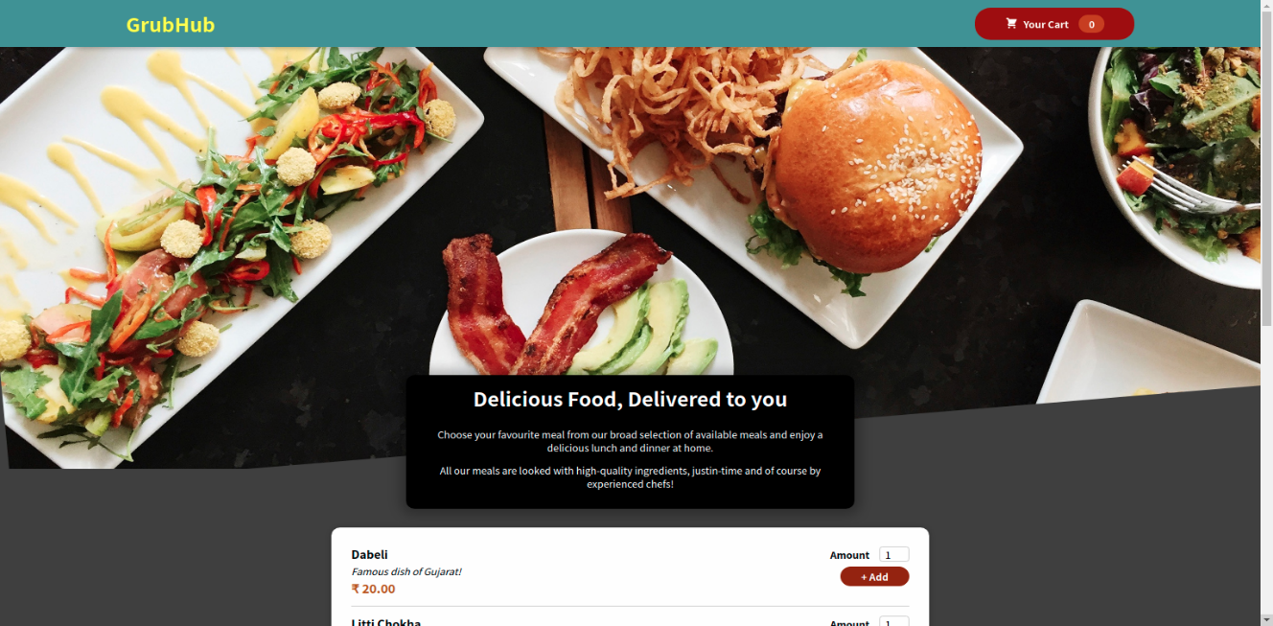

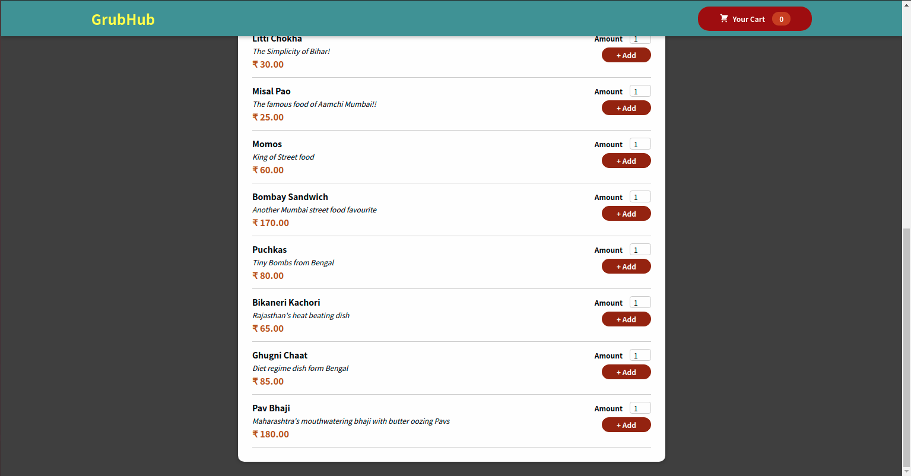

### ADDING TO THE CART

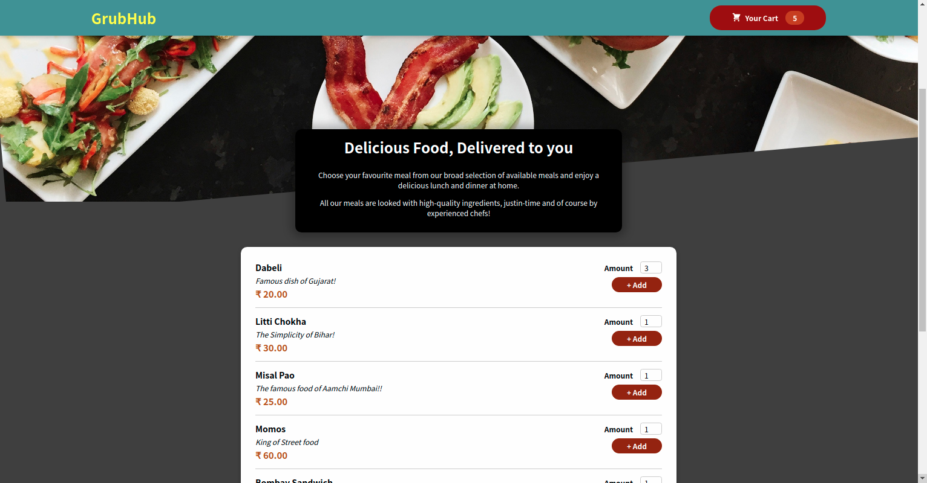

### VIEWING CART

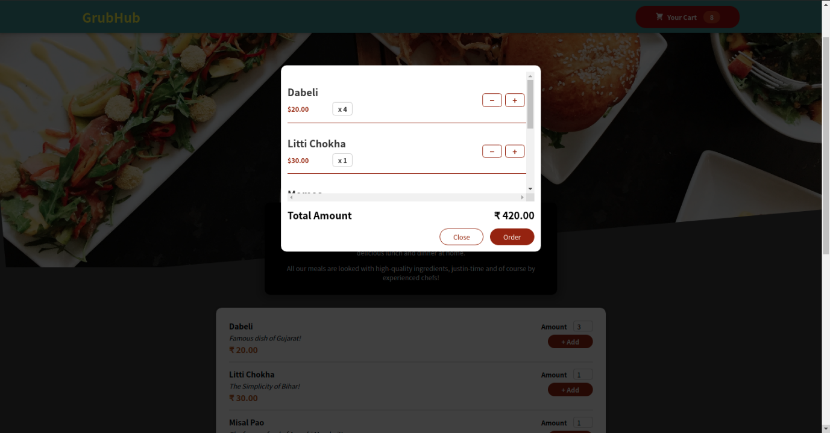

### FORM DETAILS TO ORDER

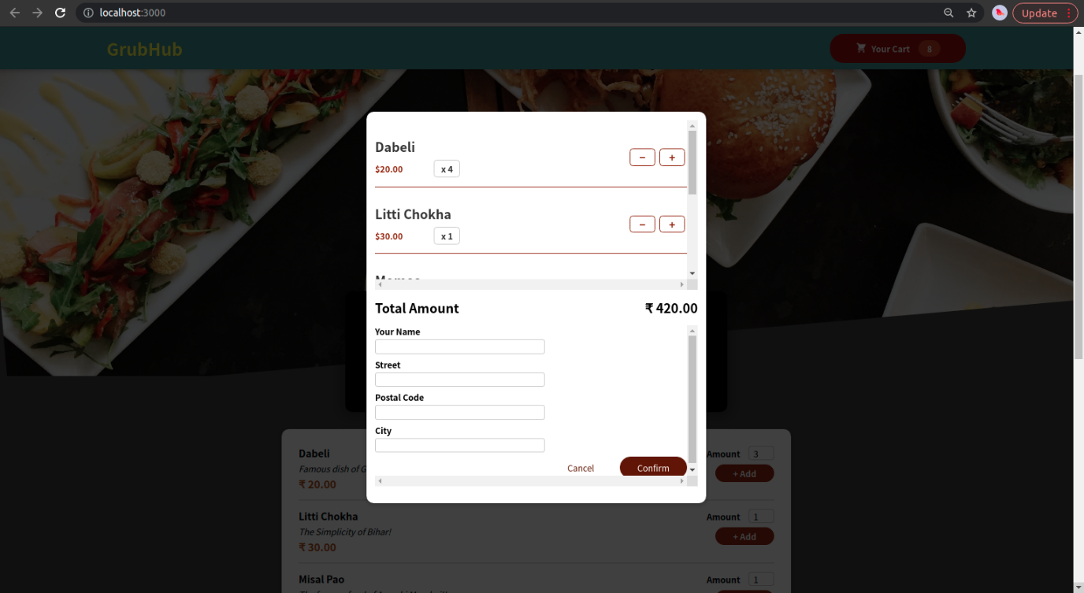

### FORM VALIDATION WHILE ORDERING

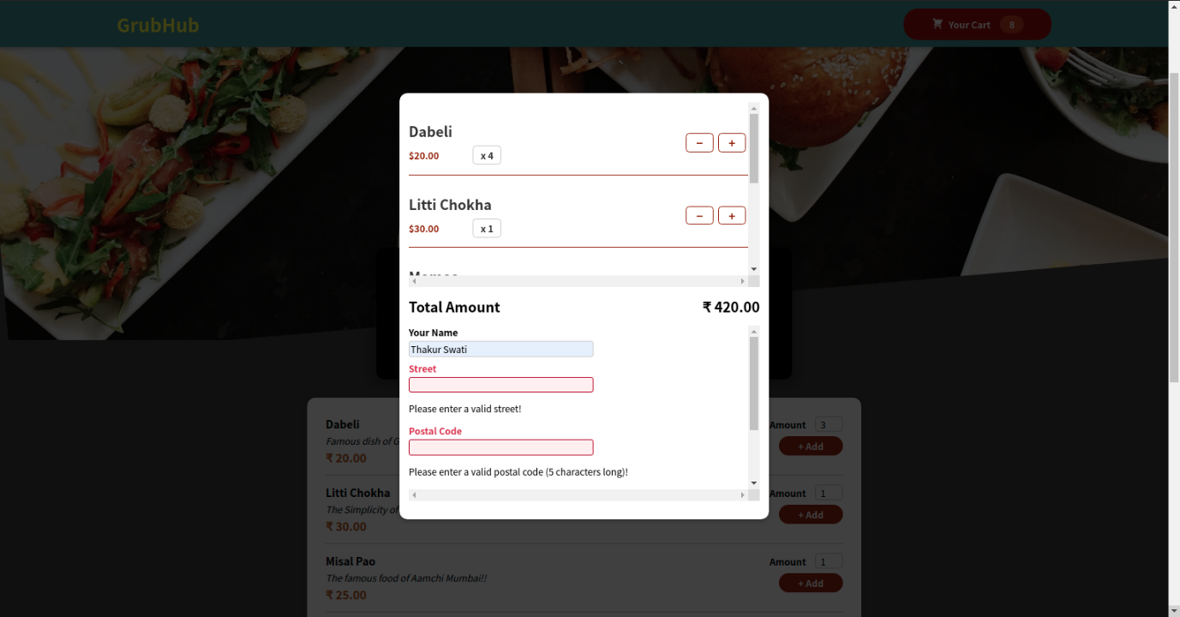

### SUCCESSFULLY ORDERING FROM THE CART

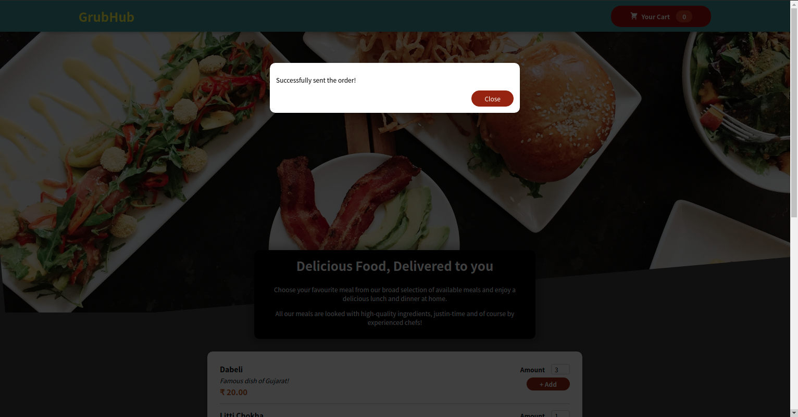

### EMPTY CART AFTER ORDER

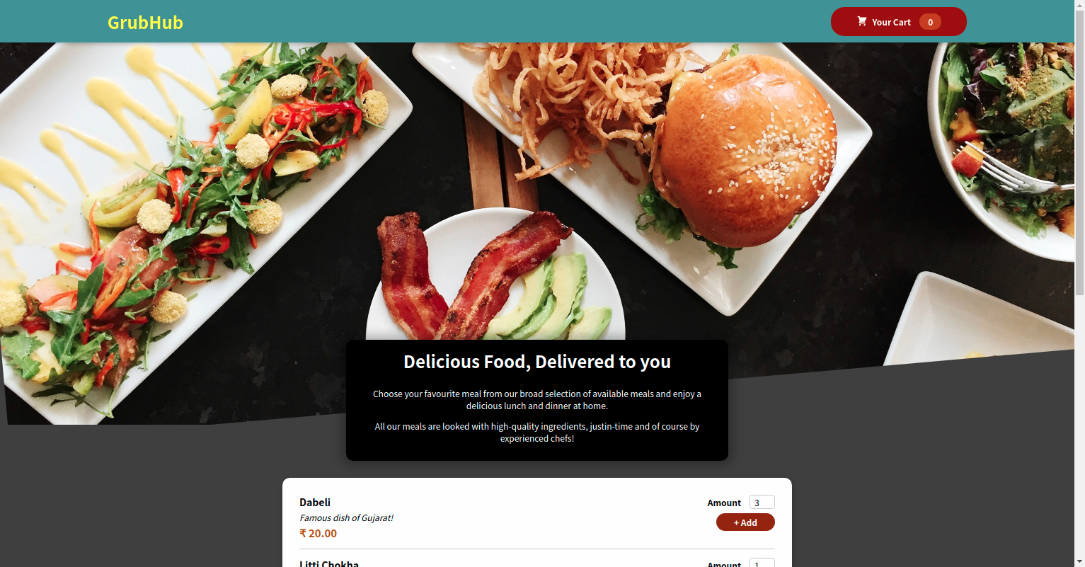

### MEALS DATABASE

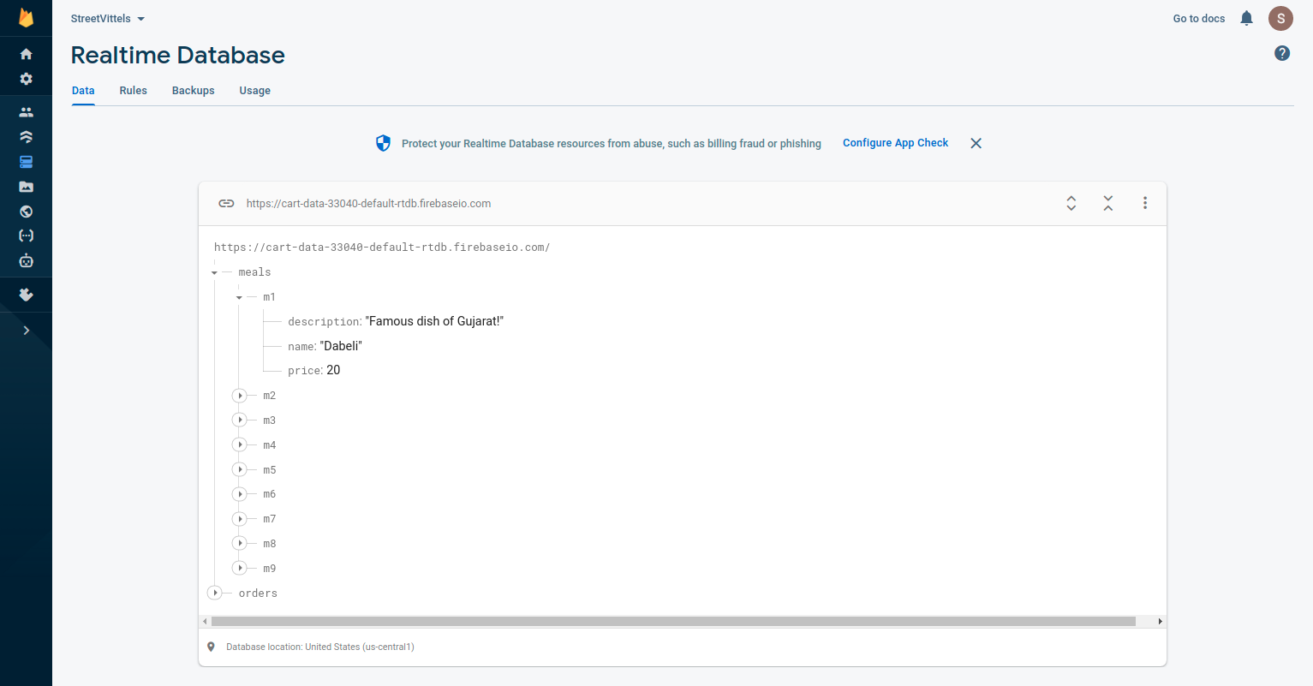

### RECEIVED ORDERS DATABASE

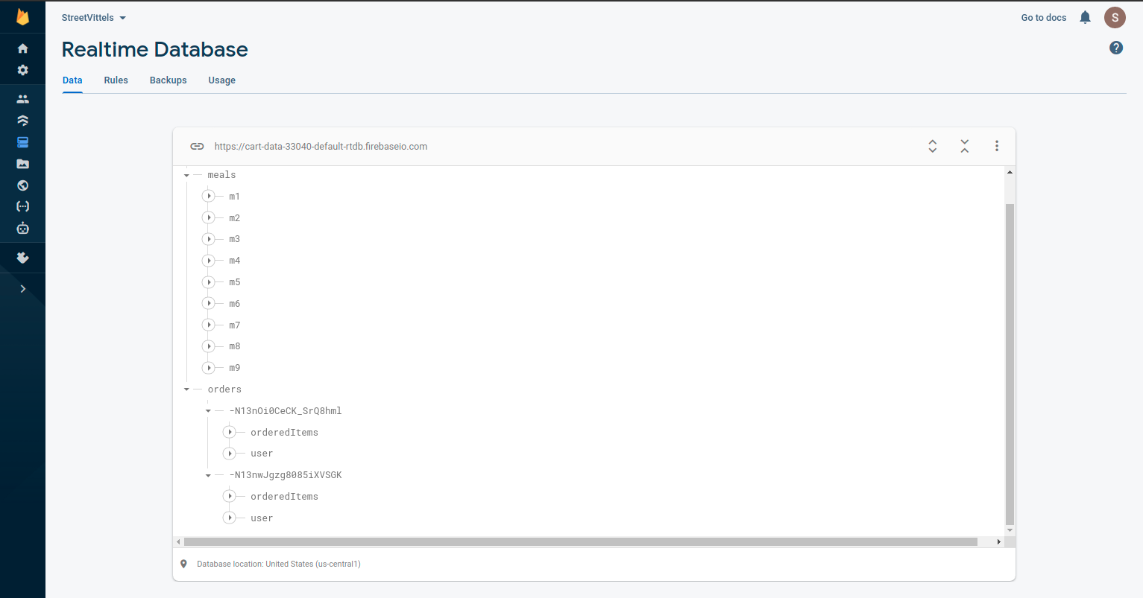

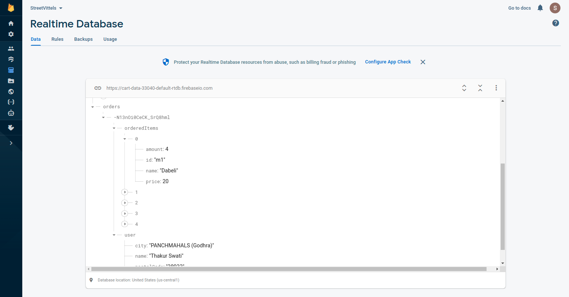

### REACTIVE USER INTERFACE

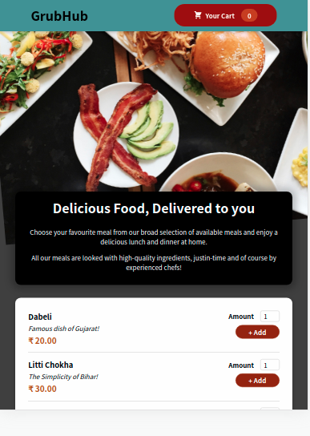

# Conclusion and Future Scope

In conclusion an online food ordering system is proposed which is useful in small family run restaurants as well as in places like college cafeteria, etc. This project can later be expanded on a larger scale.

References

**Web references**

1. [Online] <https://www.w3schools.com/>
2. [Online] <https://www.tutorialspoint.com/index.htm>
3. [Online] <https://stackoverflow.com/>
4. [Online] <https://www.javatpoint.com/>
5. [Online] <https://www.udemy.com/>
6. [Online] <https://reactjs.org/>
7. [Online] <https://firebase.google.com/>